Table of Contents:
- Display Technology
- Imaging technology
- Lenses
- Existing VR headset screen/lens specs

Near Eye Displays (NED)
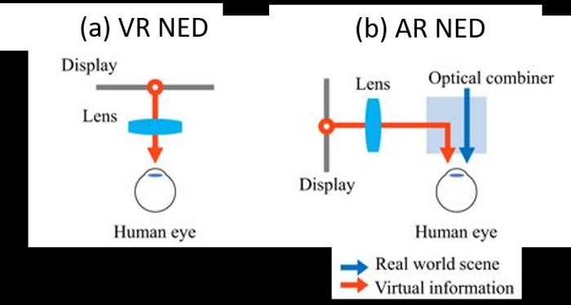

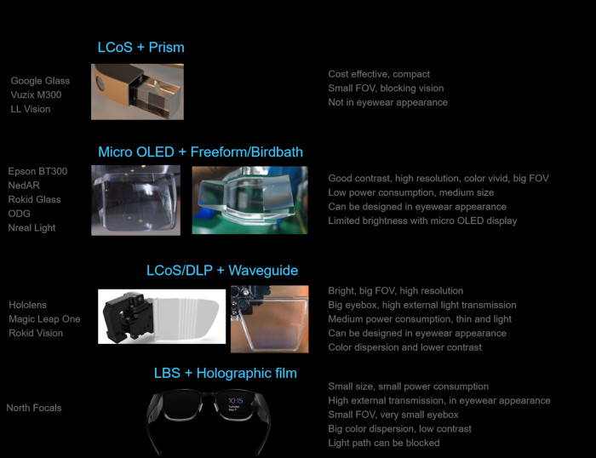

Google glass used a LCoS microdisplay with a prism that redirected the light 90 degrees
Finding and working with a microdisplay seems possible, working with the prism seems a bit beyond our capabilities, unless we can find a product already created.

Waveguides:
Waveguides is a term often used to refer to the lens or piece of material that you look through to see the AR image

“Waveguides are thin (about 1 mm thick for each individual plate), transparent, optical elements that take a projected virtual image and relay it to the eye while expanding the exit pupil (viewing window) at the same time.”

Sources:
https://virtualrealitypop.com/understanding-waveguide-the-key-technology-for-augmented-reality-near-eye-display-part-i-2b16b61f4bae
https://uploadvr.com/waveguides-smartglasses/

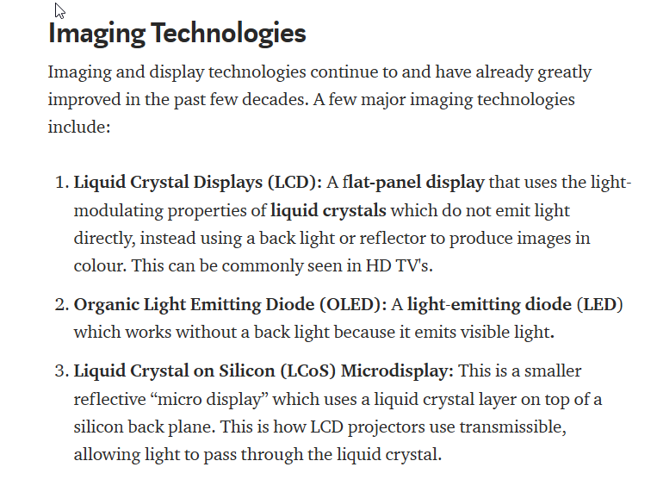
https://medium.com/@alishbai734/how-display-technologies-work-in-ar-vr-6448445fc9ca

