Lenses:
Concave lenses: fix nearsightedness
Convex lenses: fix farsightedness
Cylindrical lenses: fix an astigmatism (30% of US is affected to some extent - although not all cases need correction, 70% of prescriptions include correction for this)
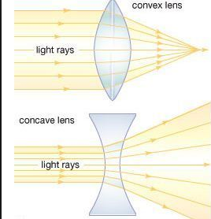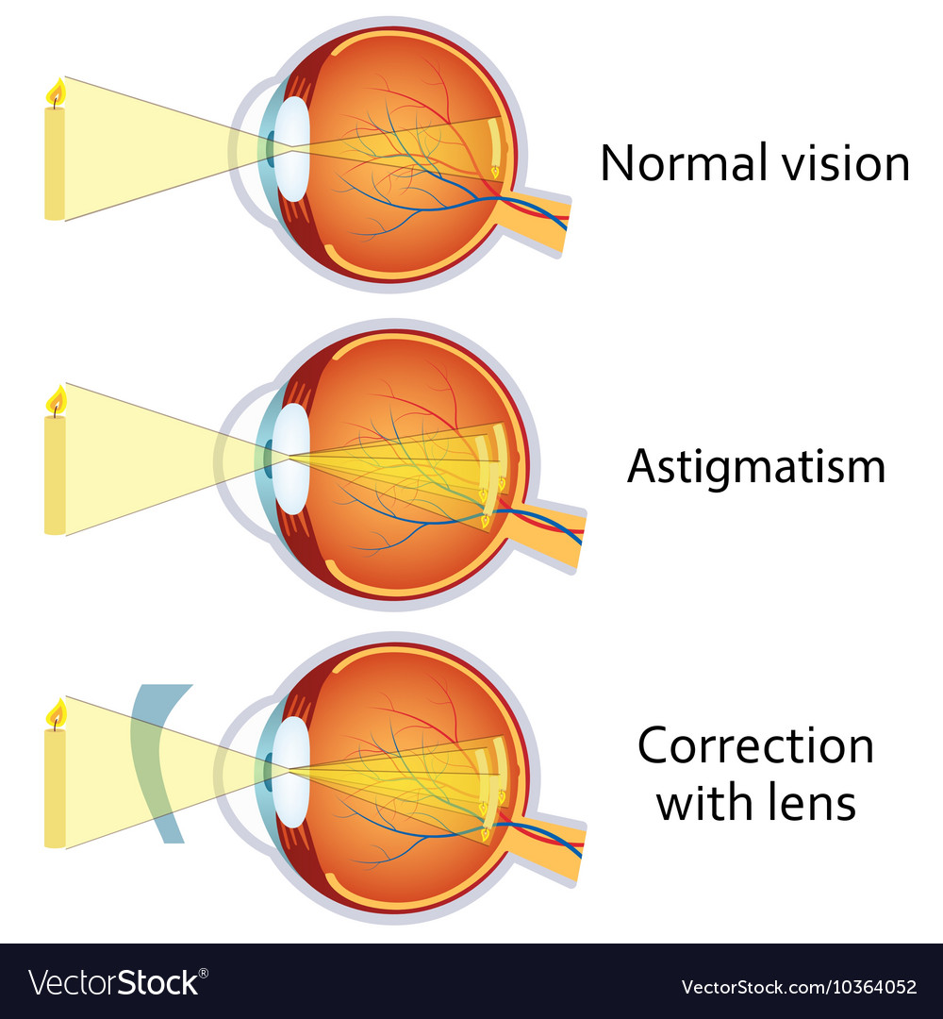

Challenges:
- Each eye is different
- Multiple types of lenses
- Not sure if the distance between the eye and the lens can account for all sight problems
- Glasses are complex and expensive, how could there be an easy fix with a single lens
- Sources suggesting that it isn’t worth not wearing glasses in a vr headset
  - https://www.vrbound.com/guides/do-you-even-need-to-wear-glasses-with-vr
  - https://www.cnet.com/how-to/how-to-wear-an-oculus-rift-and-htc-vive-with-glasses/#:~:text=Unfortunately%2C%20your%20glasses%20will%20either,fit%20over%20them%20just%20fine.&text=Before%20you%20shell%20out%20a,sure%20they'll%20fit%20inside.
- Potential solution: block frame where camera may be stored
Eye statistics:
- 64% of people wear glasses
- 70% of prescriptions include correction for astigmatism (not fixable by binocular lenses)
- 11% wear contacts

Binoculars:
- Fixes near and farsightedness but not binocular lenses

How VR lenses work: https://vr-lens-lab.com/lenses-for-virtual-reality-headsets/
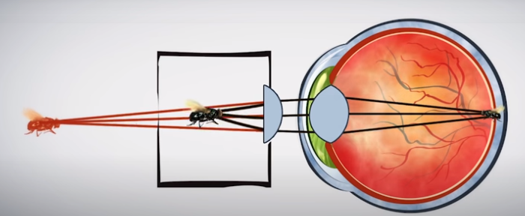
- When the object is far away, the eye lens is most relaxed. Eye lens cannot bend enough if item gets too close, in VR since screen is much closer to the eyes, an additional lens between your eyes and the screen redirects the light outward, so object perceived to be farther aware that the screen actually is

Research to continue on:
- Astigmatism correction
- LCD strain on eyes
- Virtual image strain
- Vr optics
- Binocular technology
  - http://www.madehow.com/Volume-7/Binocular.html
  - https://www.reddit.com/r/Binoculars/comments/9duyqu/what_kind_of_binoculars_are_right_for_someone/

Optics Experts:

(from Rover)

Dr. Lathrop in ComS - practical information from gaming and other applications.
https://www.news.iastate.edu/news/2017/04/26/integratedreality (a few years old but I assume might still be a good resource)
https://www.cs.iastate.edu/people/james-lathrop

The VRAC center and HCI faculty are potentially good sources, although it’s sometimes hard to find out who is available to answer questions.
For example, http://www.vrac.iastate.edu/facilities/metal/

A long-time VRAC leader, Dr. Jim Oliver, is now the director of the new Student Innovation Center. The SIC is a resource that is supposed to be helping students with design projects.
https://www.sictr.iastate.edu, https://www.imse.iastate.edu/directory/profile/oliver/
https://www.sictr.iastate.edu/2020/01/15/kaitlyn-ouverson/ -- might have leads through other students

EE perspective is Dr. Jae Kim. He does optics work at the microelectronics level, and while applied, I’m not sure about his expertise at the level of your project.
https://www.ece.iastate.edu/profiles/jaeyoun-kim/, https://sites.google.com/view/jaekwangkim/home, statistics professor

(other)
- Other physics professor, optics, modern optics course

TODO:
- Existing research by VR companies

Notes from Jim Oliver:
“Yes, most commercial HMDs are designed to accommodate eyeglasses, although some folks find it a bit more uncomfortable with glasses. There are many advances happening in this area, mostly focused on resolution and field of view enhancements. For example, check out Varjo: https://varjo.com

Some HMD’s are attempting to incorporate eye tracking within the system. In addition to providing information on what the subject is paying attention to (which is useful in many research applications), some are using this information to implement “foveate rendering”. This is a technique that provides more visual realism in the direction you are looking, since more of our visual acuity is within a 10 degree cone around your focal vector.

One of the big challenges for AR glasses is making them adaptable to common vision issues, like myopia. If your “normal" glasses could also provide AR content and you would have a winner. Rumor has it that Apple is close to having this capability.

Finally your question about usage… in my experience, most folks can stand about 15-30 minutes of use before giving up. It is usually a combination of ergonomics (comfort) and being disassociated from the physical world. Others complain about being tethered and getting tangled in the cord (hence the move to tether-less HMDs) or cyber-sickness, but there are many variables associated with that.

Eye strain is usually not a problem as most HMDs have adjustments for inter-pupillary-distance (IPD). If you don’t get the distance between your pupils right it can mess up the stereoscopic effect, cause eye strain, and perhaps even exacerbate cyber sickness.”

Additional resources:
https://www.vrbound.com/guides/which-virtual-reality-headsets-can-i-wear-with-glasses
https://www.vrbound.com/guides/do-you-even-need-to-wear-glasses-with-vr
https://vr-lens-lab.com
- Summary of articles: there are available lenses for sale for VR, most headsets allow room for glasses, farsightedness vision is accommodate with VR but nearsightedness is not

